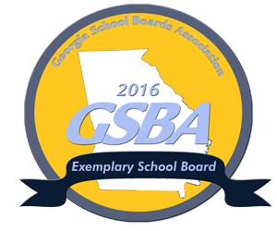
McDuffie County School District Achieves 2016
GSBA Exemplary School Board Status
December 7, 2016– McDuffie County School District is proud to announce the achievement and status of the Georgia School Boards Association’s (GSBA) 2016 Exemplary School Board recognition.
The recognition program was designed to showcase best practices in school governance and leadership. GSBA recognizes good school board governance to foster educational community cultures in order to advance student learning and achievement.
McDuffie County School District met and or exceeded the criteria set forth by GSBA to earn this honor of a 2016 Exemplary Board. The criteria may be reviewed by clicking visiting www.gsba.com for more information.
The GSBA Governance Team Recognition Program was developed by Georgia superintendents and board members based on the state board of education’s standards for effective governance to recognize exemplary leadership.
In 1998, the Georgia School Boards Association was one of the first school board associations in the nation to develop a program of standards for local boards of education.
The GSBA Board recognition program is a three-year, three tiered program. For more information on the program you may visit the GSBA website for awards and recognition to view the criteria for all tiers of the program.

