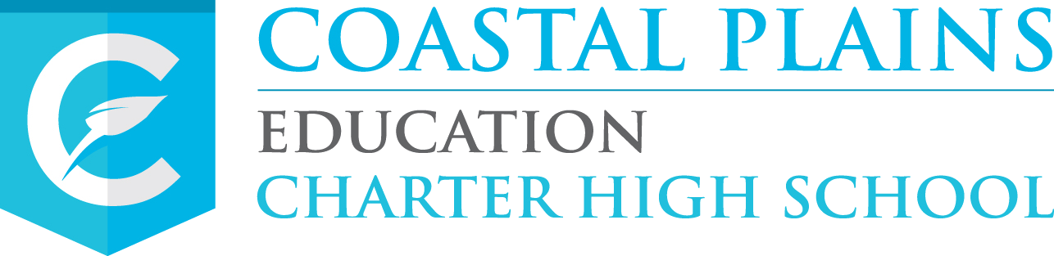

**Each Team Consisted of:**

1 Content Leader

2 Coastal Content Teachers

1 Special Education Teacher

Curriculum Teams were developed for:

10th Grade Literature Statistics

12th Grade Literature Advanced Algebra

World History Chemistry

Government Environmental Science

* Encourage more teacher interaction

* Identify & support “bubble students”

* Encourage more verbal communication between teachers & students

* Review LiveBinder

* Provide teachers with a student/mentor list

* Better awards for students that pass the EOC

* Attendance Competition

* EOC Competition for above average scores

* Ring a bell every time a student completes a course

* Poster of estimated time to complete each course, w/ # of modules

* Enroll students in easier courses first

* Celebrate success

* Hire tutors for Economics

* Post tutor schedules for students

* CELEBRATE more often

 Group students in the room based on course taking

 Review test scores and meet with students on progress

 Have guided notes in all subjects

 Post a reward wall in each room & hallway

 Post teacher schedules, so students know who is working when

August Grant News

JULY KICKOFF INSTITUTE CURRICULUM TEAMS INSTRUCTIONAL COACHES

# **July Kickoff Institute**

During the July Kickoff Institute, the Data Team Managers spent multiple days conducting an analysis of the 2017-18 Milestones EOC assessment data for Coastal Plains Charter, as well as reviewing assessment practices and topics in regards to the EOC and annual GaDOE CCRPI accountability reports. The following topics were reviewed:

* The structure of the Milestones EOC assessments
* Analyzed quality assessment items
* The alignment between the DOK) level of the GSE and the assessment items found on the EOC.
* Analyzed the domain level performance for Coastal Plains students for all eight EOC assessments, and identified the strength and challenge areas for each course.

The team also received an update about the revised 2018 CCRPI components (due to ESSA) and the use of weighted percentages for the calculation of CCRPI component scores with EOC data.  Following this update, the data team managers used the standard error of measure (SEM) data from the 2017-18 EOC to identify Coastal Plains students closest to the next level of performance.  Finally, the team identified the data points that would be summarized and reviewed on a regular basis during the school year and how the data would be shared with each Coastal Plains site throughout 2018-19.

Curriculum Teams- Eight Teams began their work on course modifications and enhancements. The focus of the teams’ work consisted of taking a detailed look at the alignment of existing GradPoint courses to the Georgia Standards for Excellence (GSE). Teams drilled down to the element level and began to look at content weight and how that compared to the number of modules within each course. Following an extensive analysis of the existing courses, the teams began the process of tagging the modules and units that will remain in the new courses to the standards and elements of the GSE. This work will continue until our October face-to-face meeting, where teams will begin the process of modifying content and adding new content to fill in the gaps of these courses.

INSTRUCTIONAL COACHES

This group will be responsible for leading department chair meetings and working with teachers to improve student learning outcomes. Each instructional coach, from the original six sites, will be paired with a BetterLessons Coach to work on Academic Coaching Goals. Together they will set goals, meet virtually once a month, and keep a log on the Instructional Dash Board provided by BetterLessons. Each site will have an Instructional Coach for Math, ELA, Science, and Social Studies.

The coaches reflected on what was working in each department and developed a list of next steps for improvement for the upcoming year. Below is the list developed by this team to focus on for their school: