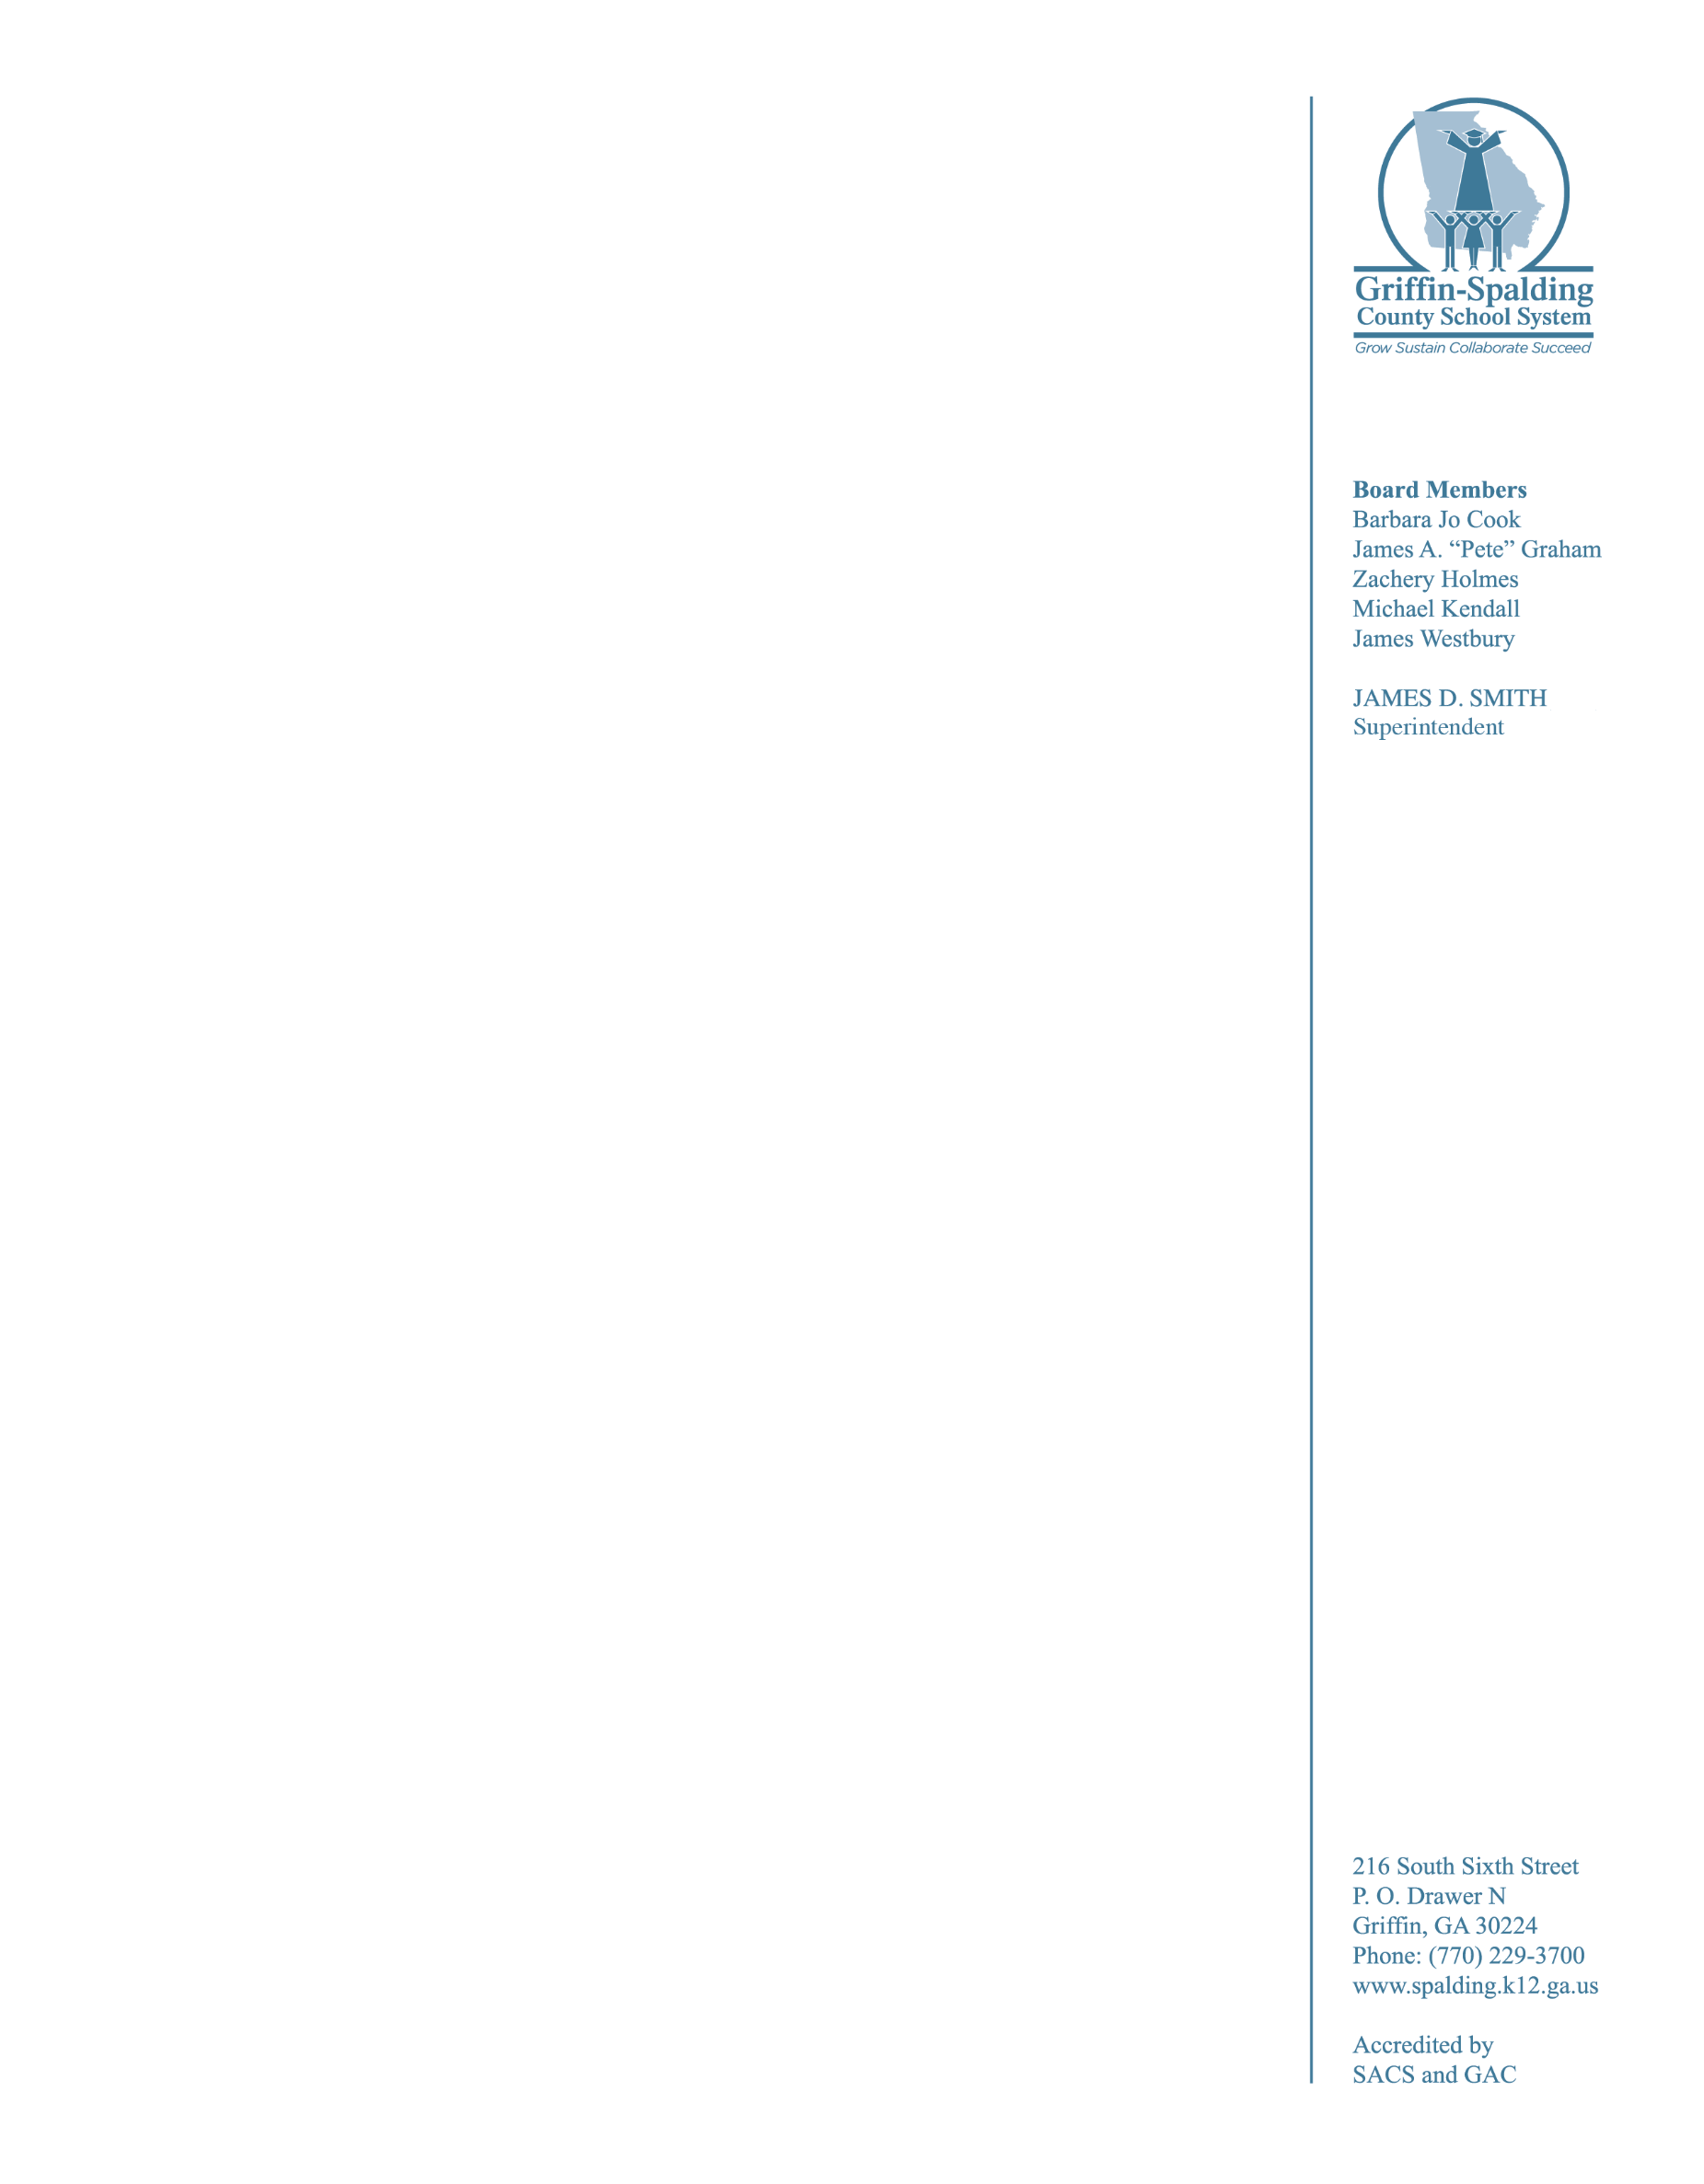

July 13, 2016

Contact: Judy Parker, APR, 770-229-3700 or judy.parker@gscs.org

For Immediate Release:

**GSCS Plans for Back to School**

School opens August 3 for Griffin-Spalding County School System’s families.

GSCS hired over 150 new teachers for the 2016-17 school year. Pre-planning for GSCS teachers and administrators will be the week of July 25 – 29. The annual Education Celebration will be held on July 27.

All GSCS schools will host an Open House on July 28 from 3 pm – 7 pm. This open house gives families a chance to tour their school, meet teachers and administrators, ask questions and get any needed information. The first day of school for students will be August 3. School times will remain the same as last year (elementary: 8 am – 2:50 pm; middle: 8:30 am – 4:00 pm; High: 7:40 am – 3:20 pm).

Other key dates for the 2016-2017 school year include:

• Aug. 18: Elementary Curriculum Night

• Aug. 23: Middle School Curriculum Night

• Aug. 25: High School Curriculum Night

• Sept. 5: Labor Day holiday

• Oct. 10 - 17: Fall break

• Nov. 21-25: Thanksgiving break

• Dec. 19-Jan. 4: Christmas break

• Jan. 9: Report Cards Issued

• Jan. 16 MLK Jr. Holiday

• Feb. 20-27: President’s Day holiday/Winter break

• March 20: Student Holiday for Professional Learning

• March 23: Report Cards Issued

• April 17-21: Spring break

• May 26: Last day of school

• May 26: Report Cards Issued (Elementary)

• May 30-June 1: Post-Planning for Teachers

• June 1: Report Cards (Middle & High)

Visit the Back to School section on our website at http://www.spalding.k12.ga.us to see the complete GSCS 2016-17 school year calendar. This section also includes:

• School Supply List

• Student Testing Schedule

• Transportation Information

• School Meal Prices

• Free/Reduced Meal Application

• Registration Information and Required Documents

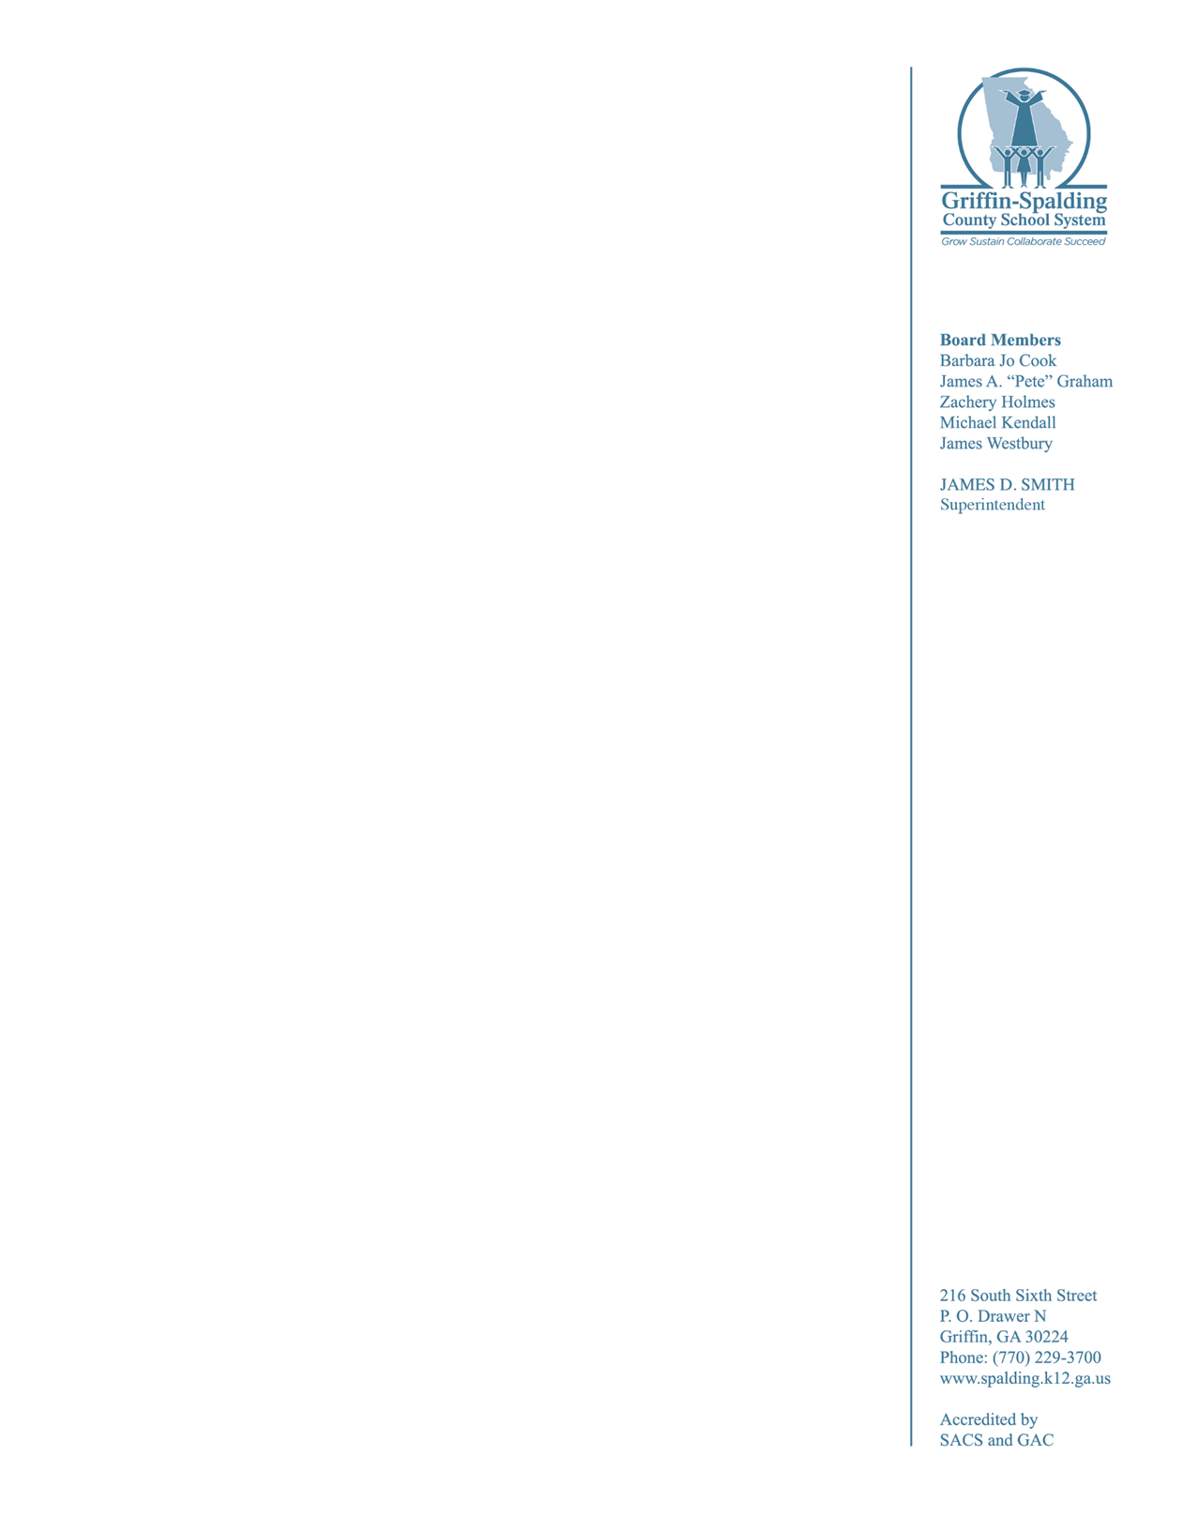

Parents or Guardians of students that have moved into Spalding County or moved within Spalding County are required to register for school at Central Registration. Avoid lines and delays by registering early. Early registration will be held July 12 – 22, Monday through Friday from 7:45 am – 4 pm at the Parent Services Center, 234 E Taylor Street. Complete the registration form online prior to visiting the Parent Service Center at www.tinyurl.com/gscsregistration.

School Superintendent Jim Smith stated, “The Griffin-Spalding County School System has planned another year of teaching, learning and student achievement. Students find success when schools are effective, families are involved and the community is engaged. Together we can transform our students into future-ready learners and contributing members of society.”

###